

Location Analysis of Possible Planting Space for Urban Forests in Austin, TX

Tree Planting Location Services (T.P.L.S)

Project Manager: Eric Fotey
Researchers/GIS Analysts:
Samantha Bechthold
William Kesler
Emily Lundy

3/1/21
Table of Contents
1. Introduction 1
2. Purpose 1
3. Scope 1
4. Literature Review 1
4.1 Benefits of Urban Forests 1
4.2 Mitigating the Effects of the Urban Heat Island 2
4.3 Environmental Justice and Urban Forests 2
5. Data 3
6. Methodology 3
7. Budget 5
8. Timetable 5
9. Final Deliverables 6
10. Conclusion 7
11. References 8
12. Appendix 8

Introduction
Sustainability is one of the most important challenges that a big city faces as it grows and expands. Austin, Texas is one of the fastest growing cities in the U.S. which makes sustainability one of its top priorities as the population continues to rise. One way that a city can boost its sustainability and combat the amount of pollution produced is to incorporate as many green spaces as possible within the city limits. Increasing the number of trees in urban areas provides numerous benefits including reducing pollution, lowering temperatures during peak summer months, providing wildlife habitat, and creating a more aesthetic appearance for the city.

Purpose
The purpose of this study is to provide our client with the total potential area within the city of Austin that can be used to plant trees. We will analyze data regarding impervious cover, tree canopy density and watershed limitations in order to provide the total area of planting space. The data used in this study has been provided by the Urban Forestry Program of the City of Austin. The analysis of this data will result in a map that portrays the possible planting space within the city of Austin. To achieve this, we will apply GIS mechanics to exclude areas that are not potential planting space. The focus of planting trees within Austin is to help reduce the total output of carbon emissions in the area as well as reduce the severity of the urban heat island.

Scope
The geographic extent is the full watershed regulation area that encompasses Austin, Texas. The project will be able to provide a rough estimate depending on urban growth in the area of where trees are able to be planted in the future.

Literature Review

4.1 Benefits of Urban Forests
Urban forests are often defined as any group of trees found within a city, town, or suburb. They provide many social, ecological, and climatic benefits. Some of the social benefits that urban forests provide are recreation opportunities like parks and trails, positive impacts on physical health as well as mental health, and reduction of sound pollution around workplaces and homes (Tyrväinen, 2010). Trees in urban areas also provide many ecological services to the city. According to the U.S. Forest Service, “urban forests help to filter air and water, control storm water, conserve energy, and provide animal habitat and shade” (Urban Forests, n.d.). They can also provide food to humans and wildlife if they are fruiting or flowering trees. Urban forests play a big part in lowering the temperature and humidity within a city, and they also help with wind control. Trees are also very effective when it comes to keeping soil from eroding away and preventing flooding. All of these benefits are prime examples of reasons that we should be investing in and protecting our urban forests.

4.2 Mitigating the Effects of the Urban Heat Island
The urban heat island effect is a phenomenon that occurs in urbanized areas that when paired with rising temperatures due to climate change, could have a negative impact on the health of people living in those areas. An urban heat island is an urban area that has a higher temperature than the rural areas around it due to all of the buildings, roads, and other infrastructure that absorb the sun’s heat during the day. Human activities also contribute to the heating of these urban areas. Urban forests are an effective way to combat this warming because they offer shade and lower the air temperatures through evapotranspiration. The EPA estimates that, “shaded surfaces may be 20–45°F cooler than the peak temperatures of unshaded materials… [and] evapotranspiration, alone or in combination with shading, can help reduce peak summer temperatures by 2–9°F” (Using trees and vegetation to reduce heat islands, 2019). These temperature differences can make a huge impact on the well-being and the quality of life of the city’s residents.

4.3 Environmental Justice and Urban Forests
Maintaining a healthy balance of urban forests within a neighborhood has a profound effect on the temperatures and therefore the quality of life of people living in those areas. Some neighborhoods have far fewer trees than others, and researchers may have found one reason why that is. Recent studies have shown that racist housing practices from almost a century ago, commonly known as redlining, have contributed to the lack of urban forests in some neighborhoods. As cities invested in parks and greenspaces, many of these redlined neighborhoods were left out, and the results of those decisions are still having impacts on people in those areas today. A study of 108 cities nationwide has shown that in almost every city studied the redlined areas were hotter than areas that were not redlined. The results showed that areas that were redlined in the 1930s are on average 5 degrees hotter than non-redlined areas, and some were even found to be almost 13 degrees hotter simply because of the lack of trees and other vegetation in those neighborhoods (Anderson, 2020). Though it may seem like a small difference in temperature, in the hottest months of the year these extra degrees can be detrimental to the health of the people living in these areas. According to an article on NPR, “Extreme heat kills more Americans every year than any other weather-related disaster, and heat waves are growing in intensity and frequency as climate change progresses” (Anderson, 2020). Studies like this one highlight why it is so important to invest in urban forestry especially in those areas that may have been affected by environmental injustice.

Data
To acquire the data to complete the analysis of potential planting space we will be given this data from our client. These data reports will include the availability of tree canopy cover, and the impervious cover within our desired study area. This area includes Austin’s city limits which is acquired by the 2010 census tract. Also, including the full watershed boundaries of 2020, which reside within the city limits of Austin. We will be conducting our data analysis within ArcGIS Pro software. Table 1 outlines the data layers and provides more information about each layer.
Table 1. Data
Entity | Attributes | Spatial objects | Status | Source | Unit | Year
Tree Canopy | Location cover | Polygon | Available | Client Data source | NAIP Imagery | 2018
Impervious Cover | Location cover | Polygon | Available | Client Data source | Digitized Data | 2019
Austin City Limits | City territory | Boundary | Available | US Census Bureau | Census tract | 2010
Full Watershed | Watershed limitation | Boundary | Available | USGS | Watershed area

Methodology
The data will be processed by using an array of geoprocessing tools including merge, clip, erase, vector to raster, and raster to vector. First, we will be using clip in order to get all the data to fit the given full watershed regulation area. Then we will use the vector to raster tool which will allow us to better manage the data due to it all being in the same format. Since the data is now in the same format, we are able to merge the impervious surface data, the canopy data and the other data we were given together creating a single layer of non-plantable space. Then we will use the erase tool on the non-plantable space layer to be able to get the layer that shows the plantable space. Once the process completes, we will begin to manually edit the data to make it easier to see and take out any outliers that don’t make sense. Once everything in the map is completed, we will then convert it back to a raster upon the client’s request. Then we will be running statistical analysis, for example seeing percentages of different specific locations in the Austin area, this includes what is the % tree canopy cover, the % potential planting space of an area, and both combined. Figure 1 is a flow chart that outlines the steps we anticipate taking throughout this project.

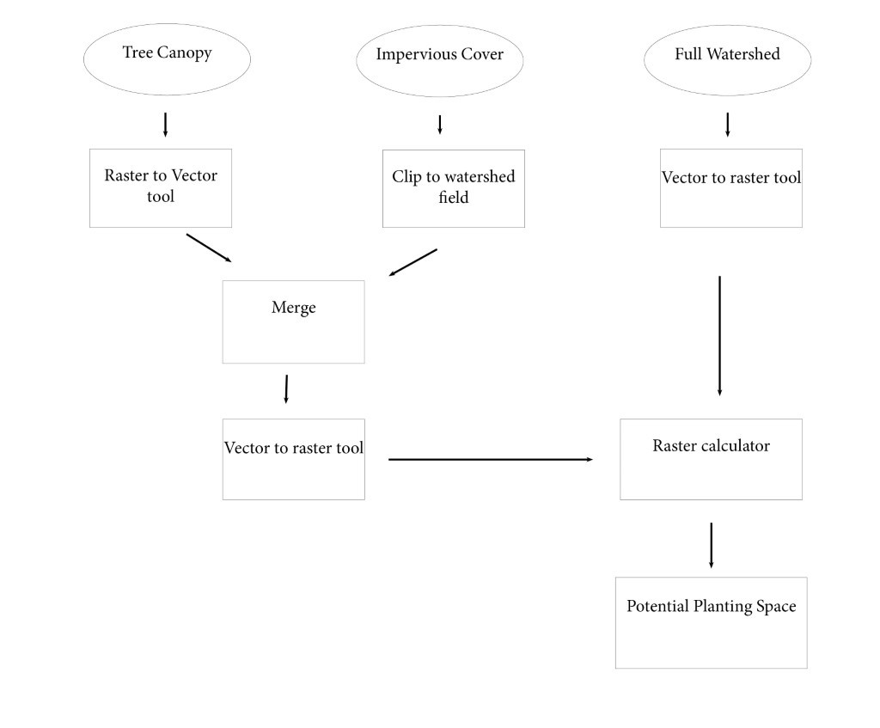
Figure 1. Flow Chart

Budget
Research fee (library use), and the use of computer resources are currently covered by Texas State University for students. Cost for these is based on the Texas State in state tuition fees breakdown, assuming an average of 9 credit hours. The budget assumes equal time spent for each consultant, at an equal rate of pay (except the project manager who will be receiving a higher salary than the rest of the consultants). Time worked may vary between phases but will average approximately ten hours per week across the entire project. Each consultant must have individual access to computers but not everyone needs library access which is factored in. The ArcGIS Subscription is a full year, but it will not be used the full duration for this project. The remainder will be covered by other projects. Table 2 shows the breakdown of the budget.

Table 2. Project Budget
Item | Breakdown | Cost
ArcGIS Business Subscription | 500 Per yr/ 12 wks | 115
Pre-Processing Data  Project Manager | 10 hrs/wk x 2wks x 40/hr x 3 consultants  10 hrs/wk x 2wks x 55/hr | 3,500
Consultation fee | 50x4 sessions | 200
Research fee | 200x 2 consultants | 200
Data Analysis  Project Manager | 10 hrs/wk x 4wks x 40/hr x 3 consultants  10 hrs/wk x 4wks x 55/hr | 7,000
Editing and Data Interpretation  Project Manager | 10 hrs/wk x 2wks x 40/hr x 3 consultants  10 hrs/wk x 2wks x 55/hr | 3,500
Use of computational resources, computers and lab | 192/semester x 4 consultants | 768
Total Cost |  | $15,283

Timetable
Table 3 outlines the basic timetable and expectations for how work on this project should proceed. Dates are flexible and subject to minor changes, however the main activities such as the 2nd and 3rd client visits as well as the final presentation will most likely not change.
Table 3. Timetable
Date | Activity | Notes
1/27 | 1st client visit | Received request for proposal
1/27 – 3/1 | Collect data | All data layers received from client on 2/15
2/15-3/1 | Create Proposal | Unable to work on proposal for the first week due to winter storm, resulted in changed timetable as of 3-1
3/1-3/2 | Edit Proposal | Make minor changes based on recommendation of Professor Yuan.
3/3 | 2nd client visit | Present proposal, make modifications at client request
3/1 – 3/15 | Pre-process data | Prepare data for analysis
3/17 – 4/7 | Data analysis | Perform GIS analysis of the data
3/24 | 3rd client visit | Give client progress report and get feedback
3/29 – 4/5 | Edit project | Make adjustments based on client’s feedback
4/7 – 4/14 | Data interpretation | Interpret the results of GIS analysis
5/3 | Final Presentation | Present final product to client

Final Deliverables
The client will receive a map of Austin showing the total suitable area for planting, as well as statistical analysis of the distribution of the suitable areas. The final analysis of this project will include a multitude of expected outcomes. This includes finding the potential planting space for the following features: the potential landcover of the full watershed regulations area, the Austin City Limits, and also the percentage of community tree priority areas. Another feature to be included will be finding the percent of existing tree canopy. Finally, the percent of the potential canopy which is constructed by the area of the percent of existing canopy and the percent of potential planting space. The Community Tree Priority Areas will be provided with highest/lowest percent for PPS, existing canopy, and potential canopy. These results will provide the client with the best suggestions for potential planting space within the Austin city limits. These priority areas will be characterized with collective attributes that describe the areas for potential space. Results will be displayed within feature classes of the provided map. A word document will be provided to identify what each feature class is representing, in order to assist viewers who may not be familiar with the subject.

Conclusion
Austin is growing at a rapid rate, and as this growth continues it is essential that plans are made to include urban forests within the city. Investing in urban forests will benefit Austin in many ways, from providing wildlife habitat and recreation opportunities to cleaning the air and lowering temperatures during peak summer months. We hope to invest in the health of the city by using GIS to determine the total possible area that can be used to plant trees and to decide which areas are of higher priority for planting. The resulting map will help policymakers in making big decisions about Austin’s urban forests, and work towards keeping Austin green.

References
Anderson, M. (2020, January 14). Racist housing practices from the 1930s linked to HOTTER Neighborhoods Today. Retrieved February 12, 2021, from https://www.npr.org/2020/01/14/795961381/racist-housing-practices-from-the-1930s-linked-to-hotter-neighborhoods-today

Tyrväinen, L. (2010). Urban forests and trees a reference book. In 1192201685 891221218 C. C. Konijnendijk (Author), Urban forests and trees a reference book (pp. 81-82). Berlin U.A.: Springer.

Urban Forests. (n.d.). Retrieved February 12, 2021, from https://www.fs.usda.gov/managing-land/urban-forests

Using trees and vegetation to reduce heat islands. (2019, December 16). Retrieved February 16, 2021, from https://www.epa.gov/heatislands/using-trees-and-vegetation-reduce-heat-islands

Appendix

Participation:

Eric Fotey (Project Manager & GIS Specialist)
Methodology, Scope

Emily Lundy (Graphic Designer, Researcher & Editor)
Logo design, cover page, introduction, literature review, conclusion, editor

William Kesler (Researcher & GIS Analyst)
Budget, timeline

Samantha Bechthold (Graphic Designer & Researcher)
Team name designer, flow chart creator, purpose, data, final deliverables

